Junle Li

Aug 10, 2020

Fundamentals of Programming: Python

Assignment05

**Introduction**

This week’s assignment is to add on codes by using Professor Root’s starter then make the script work as a program. The script prints a menu to the user and allows for users to add and delete their tasks and priorities, then organize them into a dictionary.

**Step 1: Read file and Load data**

As the variables are declared by default, the first step is to get the script to read the required file “ToDoList.txt”. To start, I manually entered a random data into the file, and have them separated by comma using row.split(“,”). Then I create dicRow to store “Task” and “Priority” data and have a strip() function to strip extra spaces. At last, append the data into lstTable and close the file.

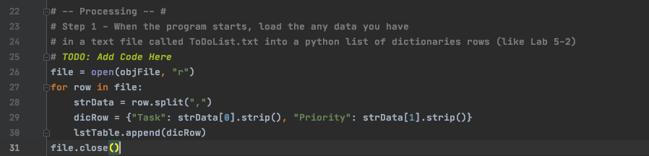

**Step 2: Display the menu**

Start of the while loop, and use print() functions to display the menu options to users, and pause for user response to the options shown. This step was done by default.

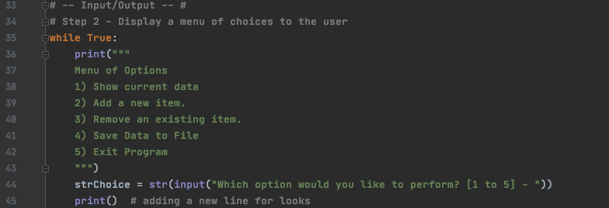

**Step 3: Option 1 - Showing current data**

After the user input their choice, we need to process the choice with an if statement when the user entered 1. Then use a for loop to go through the lstTable and print out Task and Priority data read in the “ToDoList.txt” file. Then the script continues.

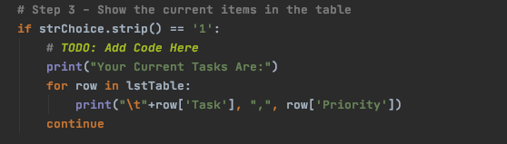

**Step 4: Option 2 - Add Data**

Used “elif” when user input 2 for the second option



This option is to allow users to add a new task and assign it with a priority. So we need 2 variables to store Task and Priority data entered by the users.



Then we need to separate these two elements and append them into the file, and tell the users they successfully added the new task. Then the loop continues.

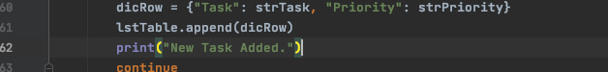

**Step 5: Option 3 - Delete tasks**

In this option, users will delete an existing data by entering the name of it. So first we need to capture what the user entered

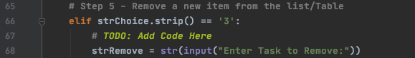

Then create a for loop to see if the users enter the name of the task correctly, if it matches the “Task” data in the file, it will remove the row and prints out a message, otherwise, it will not do anything but prints out a message asking the user to enter the correct name of the task they wish to delete.

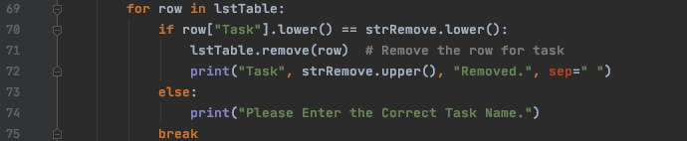

NOTE: it only allows the user to delete tasks by order, not sure what happened but will look into it.

UPDATE: Solve it by relocating the break

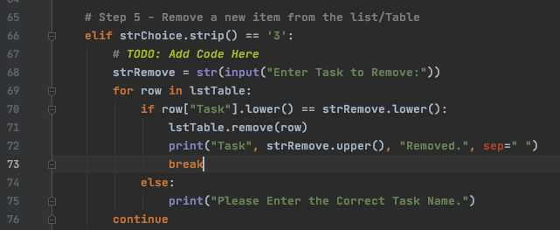

**Step 6: Option 4 - Save files**

This option allows users to save what they added or deleted by writing it into the “ToDoList.txt” file.

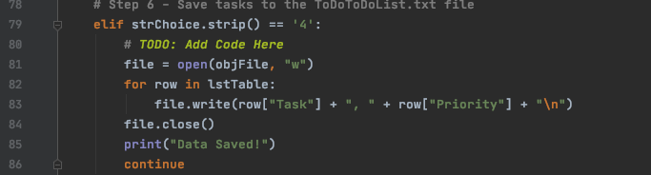

**Step 6: Option 5 - Exit**

Option 5 is simply allowing users to exit the program by printing a confirmation and the program will break when the user confirms to exit, otherwise the loop will continue.

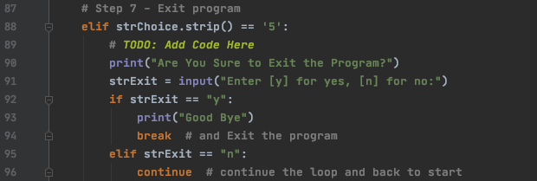

**Conclusion**:

This a more challenging script since a has more options to deal with, but the starter really helps sorting out the ideas and steps on writing the script. One minor bug comes with the deleting part where it only allows me to delete the tasks one by one and in order, if I want to delete the third task then it is not working. Not sure what happened but will look into it. (UPDATE: Issue Solved)